**Project-1**

**Title: Write a Simple HTML program for displaying ”Hello World!”:**

**Source code:**

<!DOCTYPE html>

<html>

    <head>

        <title>

            First web page

        </title>

    </head>

    <body>

        Hello World!

    </body>

</html>

**Output:**

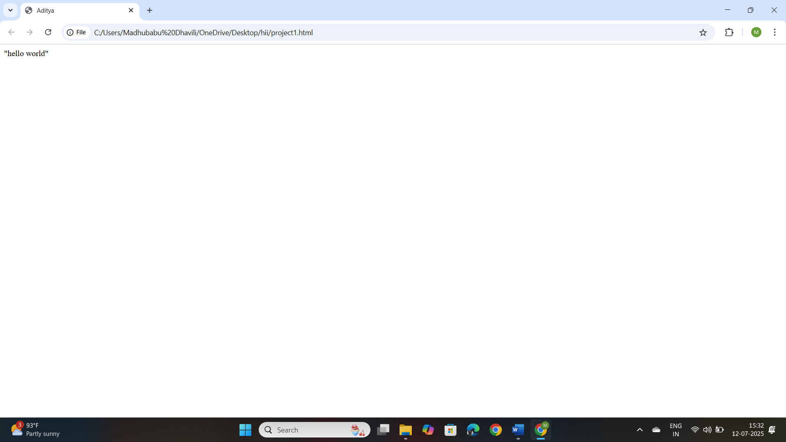

**Project-2**

**Title: Design a web page of displaying “Hello world” by using Heading Tag:**

**Source code:**

<!DOCTYPE html>

<html>

    <head>

        <title>

            Second web page

        </title>

    </head>

    <body>

        <h1>Hello World!</h1>

        <h2>Hello World!</h2>

        <h3>Hello World!</h3>

        <h4>Hello World!</h4>

        <h5>Hello World!</h5>

        <h6>Hello World!</h6>

    </body>

</html>

**Output:** 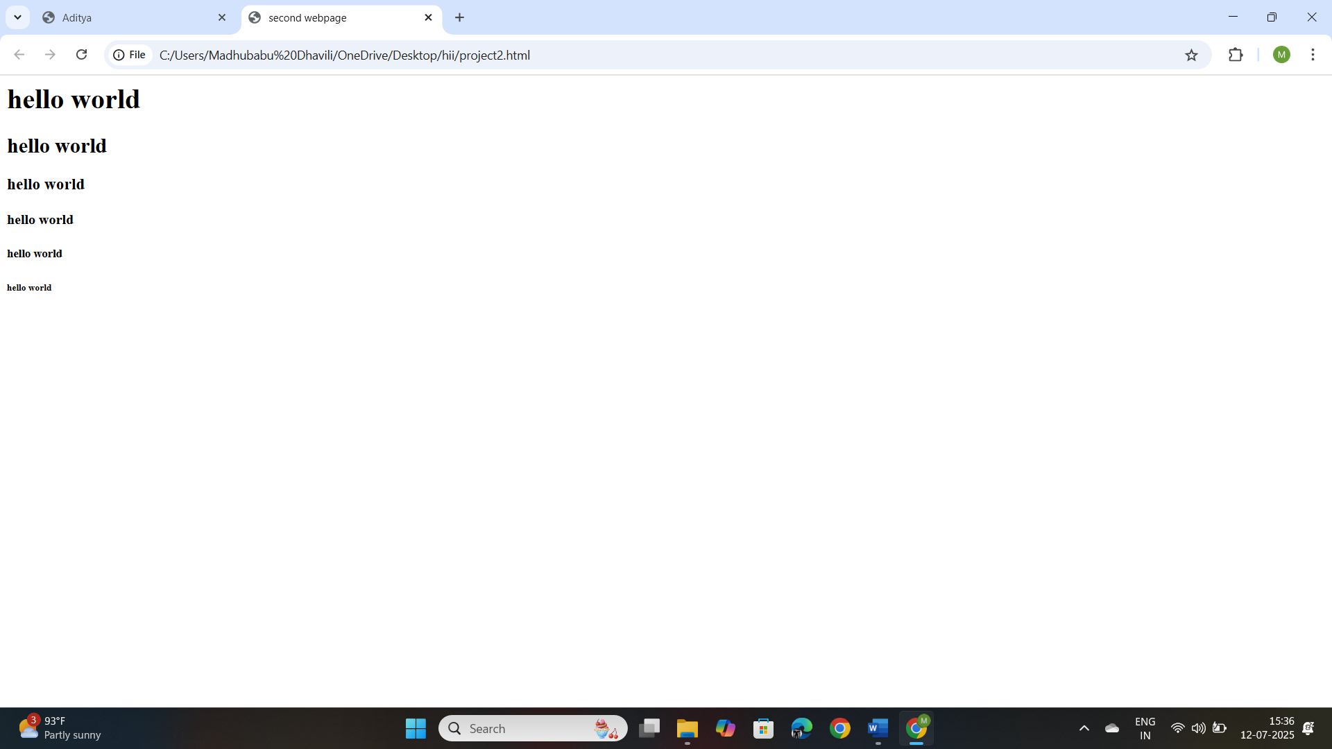

**Project-3**

**Title: Design a web page by demonstrating the usage of Paragraph Tag:**

**Source code:**

<!DOCTYPE html>

<html>

    <head>

        <title>

            Paragraph Tag

        </title>

    </head>

    <body>

        <h1>Paragraph</h1>

        <p>/This is a paragraph.<br>Adding a line break here for demonstration.</p>

        <br>

        <p> This is another paragraph.<br>Here's another line break within this paragraph</p>

        <br>

    </body>

</html>

**Output:** 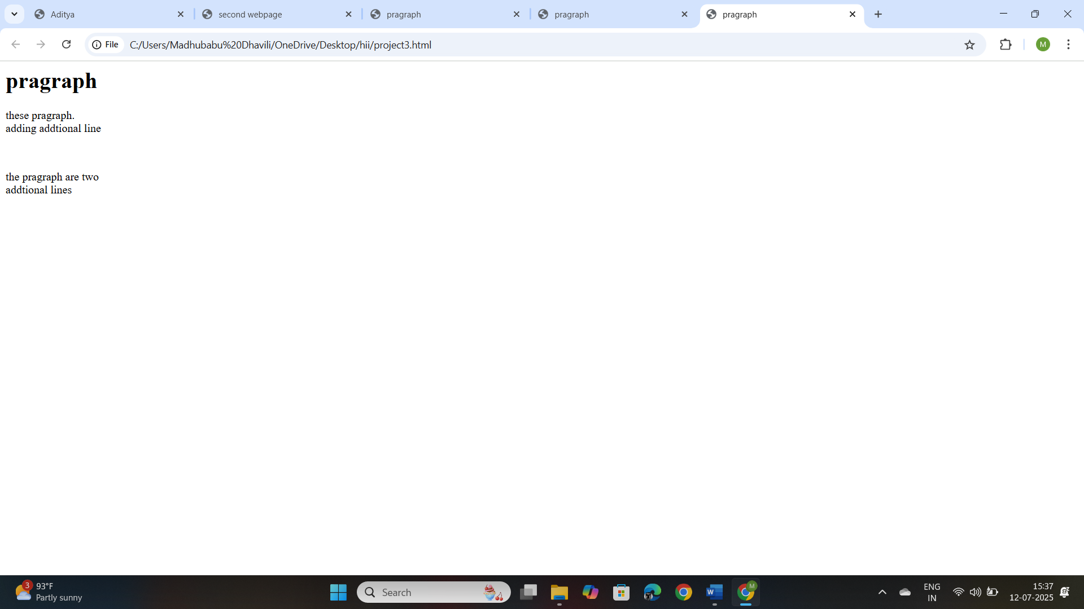

**Project-4**

**Title: Design a web page by demonstrating the usage of HTML lists:**

**Source code:**

<!DOCTYPE html>

<html>

    <head>

        <title>

            HTML lists Example

        </title>

</head>

    <body>

        <h2>Ordered list(numbered)</h2

            <ol>

                <li>Rice</li>

                <li>Sugar</li>

                <li>Dal</li>

            </ol>

            <h2> Unordered list(Bullet Points)</h2>

            <ul>

                <li>Apple</li>

                <li>Orange</li>

                <li>Banana</li>

            </ul>

            <h2>Definition List(Items)</h2>

            <dl>

                <dt>Potato</dt>

            <dd>A starchy vegetable commonly used in cooking.</dd>

            <dt>Brinjal</dt>

<dd>Also known as eggpiant, a versatile vegetable used in various dishes.</dd>

            </dl>

    </body>

</html>

**Output:**

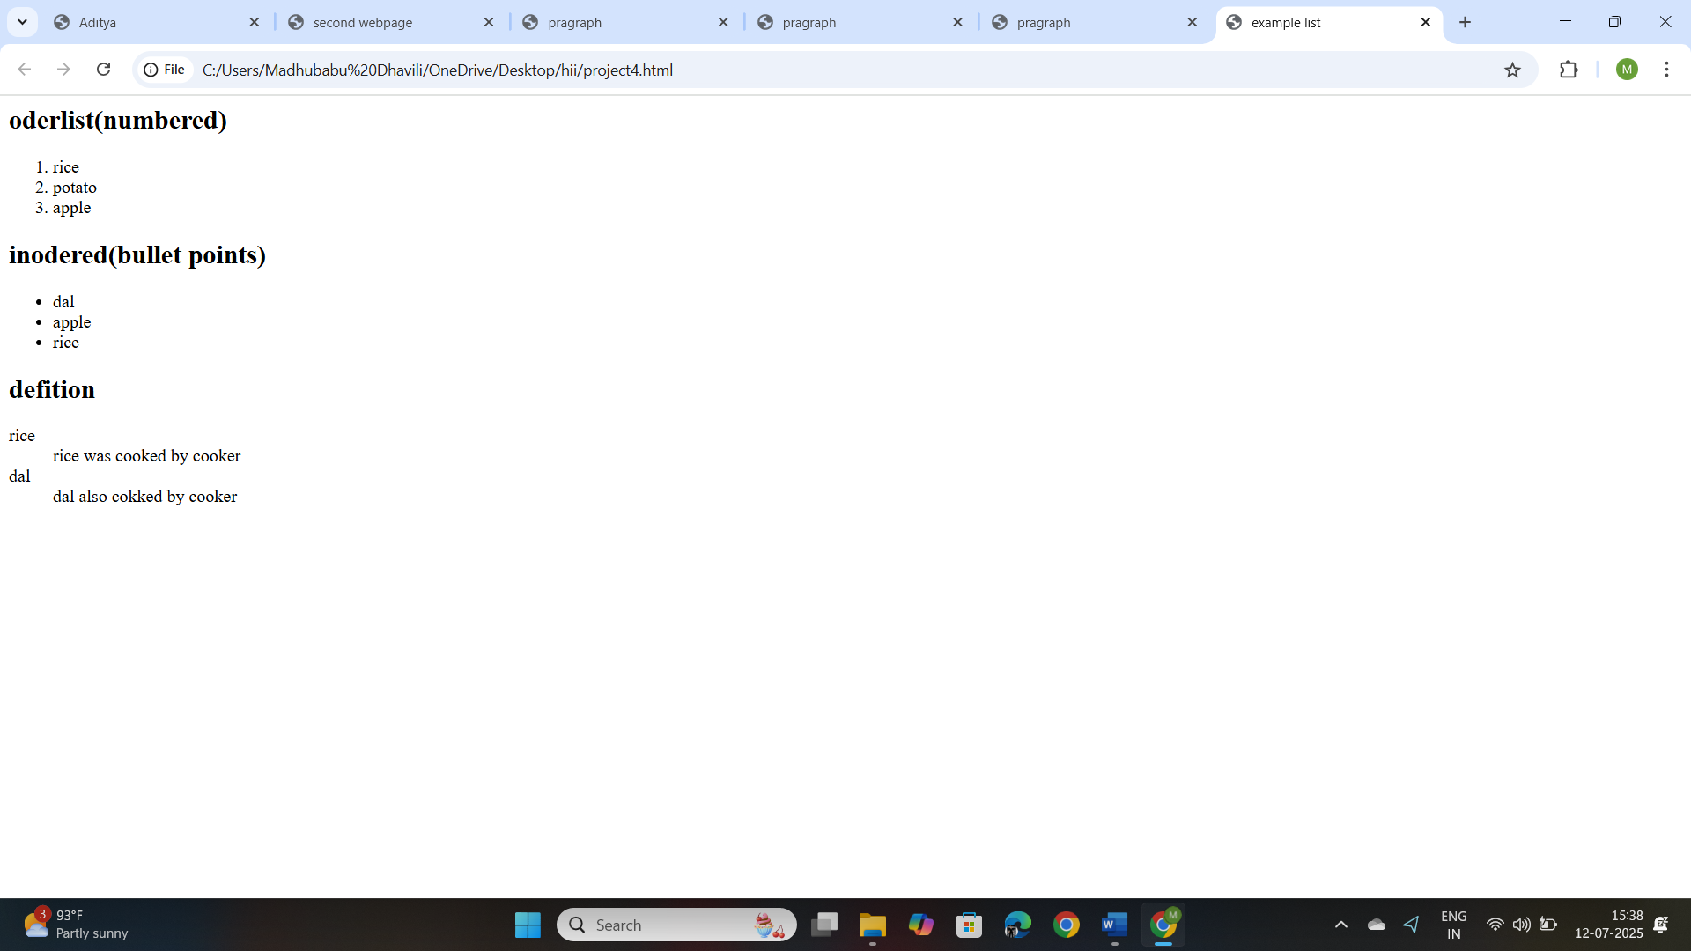

**Project-5**

**Title: To design a web page by demonstrating the usage of HTML list type attribute –“A”:**

**Source code:**

    </body>

</html>

<!DOCTYPE html>

<html>

    <head>

        <title>

            Second web page

        </title>

    </head>

    <body>

        <ol type="A">

            <li>tarun</li>

            <li>kumarI</li>

            <li>ravi</li>

        </ol>

    </body>

</html>

**Output:**

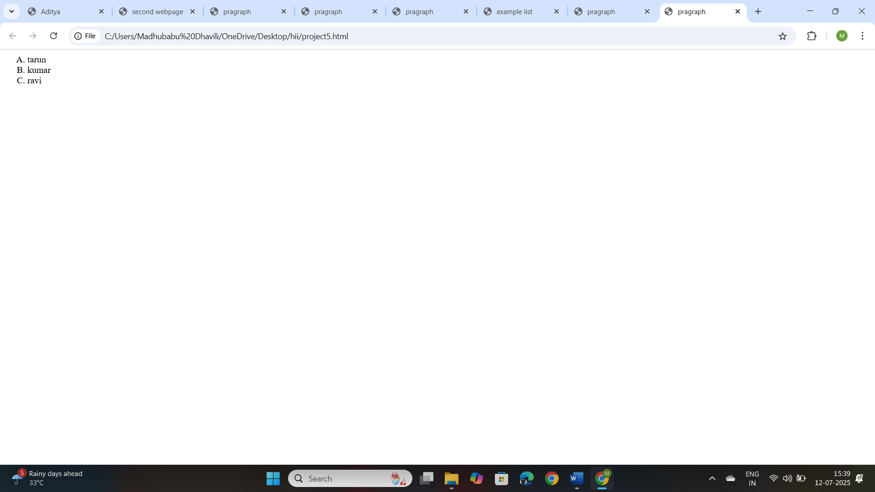

**Project-6**

**Titlte: Design a web page by demonstrating the usage of HTML list type attribute-“a”:**

**Source code:**

<!DOCTYPE html>

<html>

    <head>

        <title>

            Second web page

        </title>

    </head>

    <body>

        <ol type="a">

            <li>tarun</li>

            <li>kumar</li>

            <li>ravi</li>

        </ol>

    </body>

</html>

**Output:**

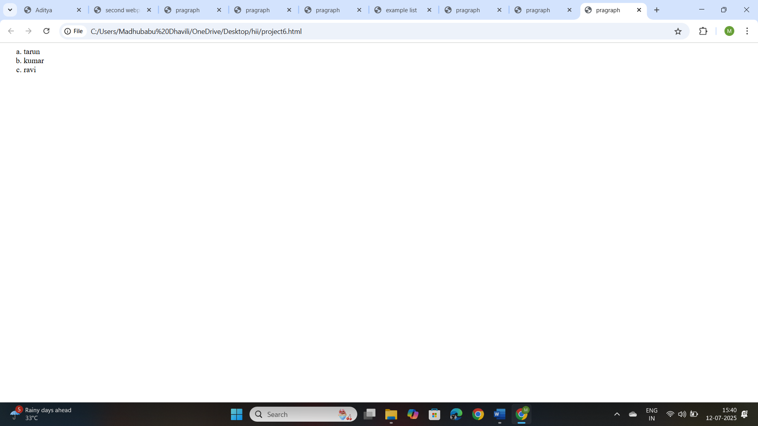

**Project-7**

**Titlte: Design a web page by demonstrating the usage of HTML list type attribute-“I”:**

**Source code:**

<!DOCTYPE html>

<html>

    <head>

        <title>

            Second web page

        </title>

    </head>

    <body>

        <ol type="I">

            <li>tarun</li>

            <li>kumar</li>

            <li>ravi</li>

        </ol>

    </body>

</html>

**Output:**

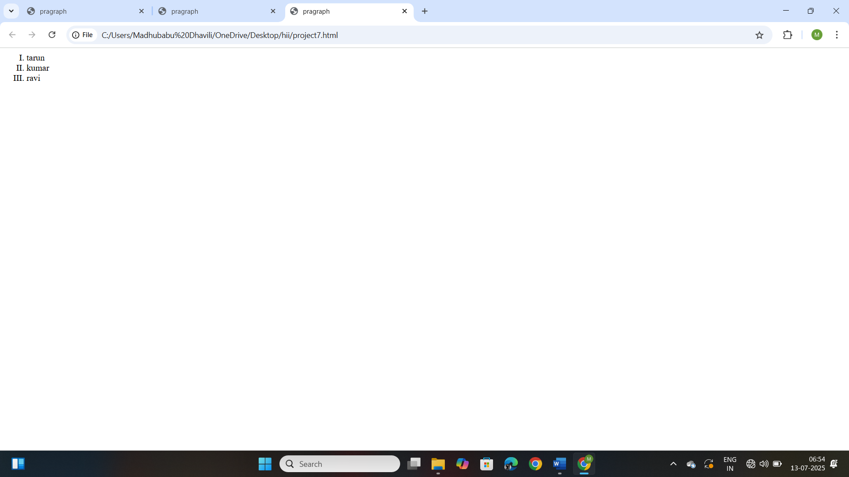

**Project-8**

**Titlte: Design a web page by demonstrating the usage of HTML list type attribute-“i”:**

**Source code:**

<!DOCTYPE html>

<html>

    <head>

        <title>

            Second web page

        </title>

    </head>

    <body>

        <ol type="i">

            <li>tarun</li>

            <li>kumar</li>

            <li>ravi</li>

        </ol>

    </body>

</html>

**Output:**

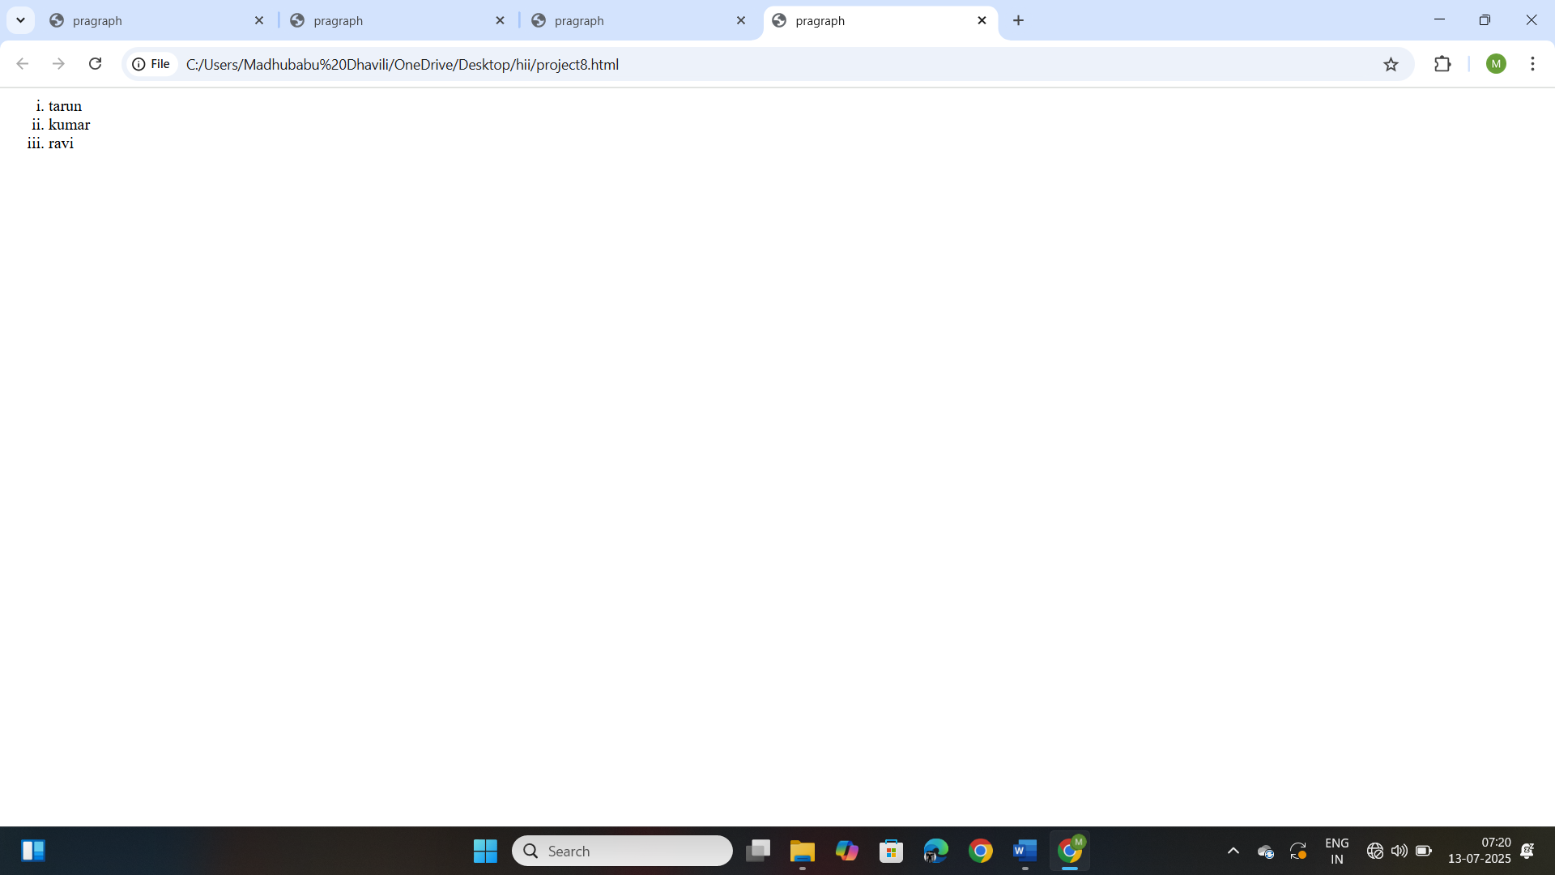

**Project-9**

**Titlte: Design a web page by demonstrating the usage of HTML list with start attribute:**

**Source code:**

<!DOCTYPE html>

<html>

    <head>

        <title>

            Second web page

        </title>

    </head>

    <body>

        <ol start="20">

            <li>tarun</li>

            <li>kumar</li>

            <li>ravi</li>

        </ol>

    </body>

</html>

**Output:**

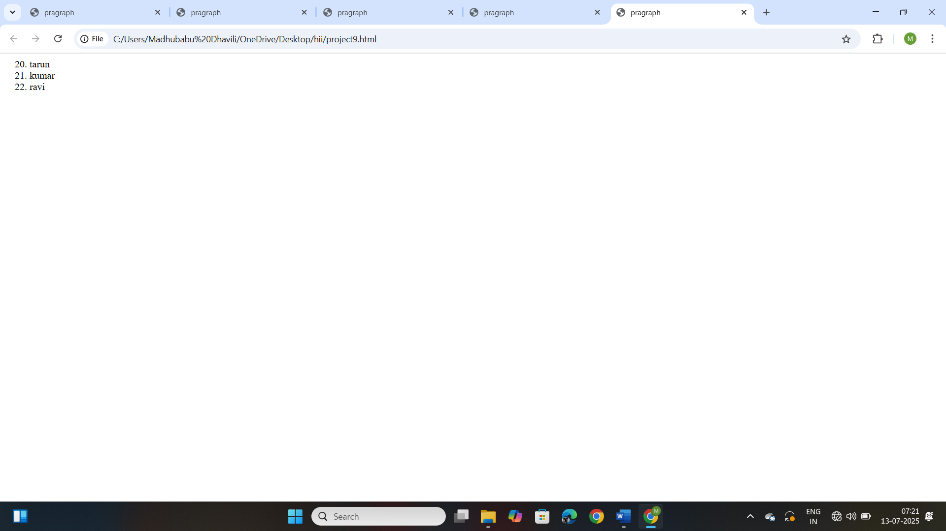

**Project-10**

**Titlte: Design a web page by demonstrating the usage of HTML list type attribute-“square”:**

**Source code:**

<!DOCTYPE html>

<html>

    <head>

        <title>

            Second web page

        </title>

    </head>

    <body>

        <ul type="Square">

            <li>tarun</li>

            <li>kumar</li>

            <li>ravi</li>

        </ul>

    </body>

</html>

**Output:**

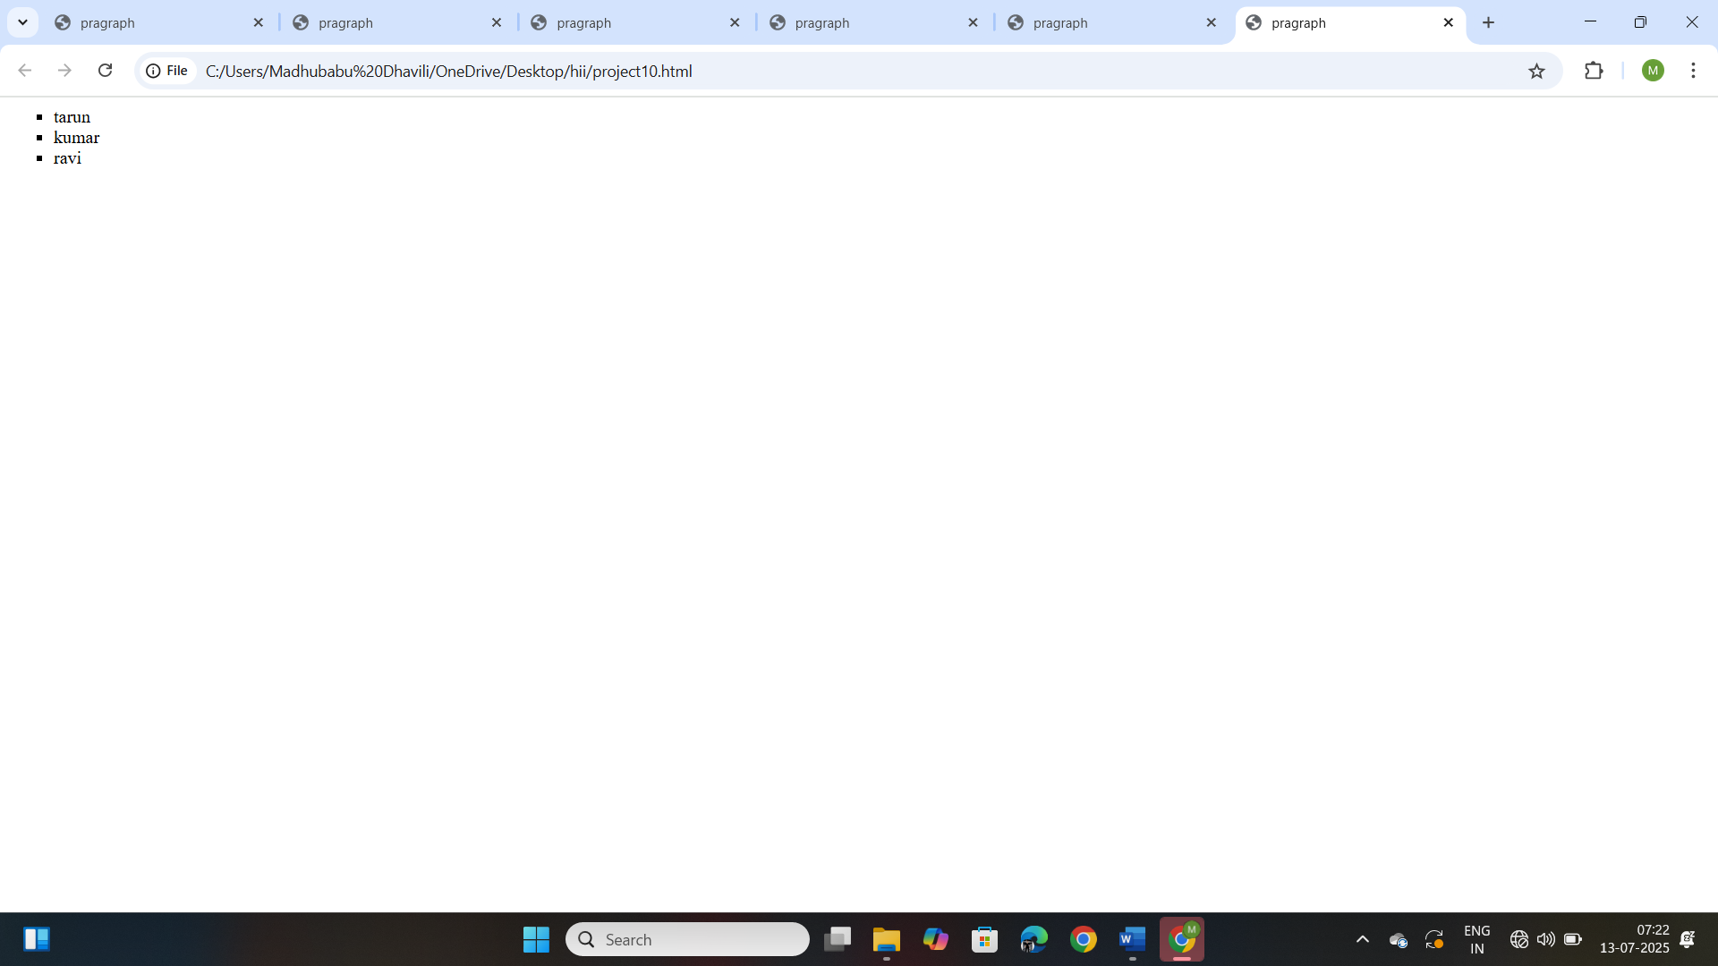

**Project-11**

**Titlte: Design a web page by demonstrating the usage of HTML list type attribute-“circle”:**

**Source code:**

<!DOCTYPE html>

<html>

    <head>

        <title>

            Second web page

        </title>

    </head>

    <body>

        <ul type="circle">

            <li>tarun</li>

            <li>kumar</li>

            <li>ravi</li>

        </ul>

    </body>

</html>

**Output:**

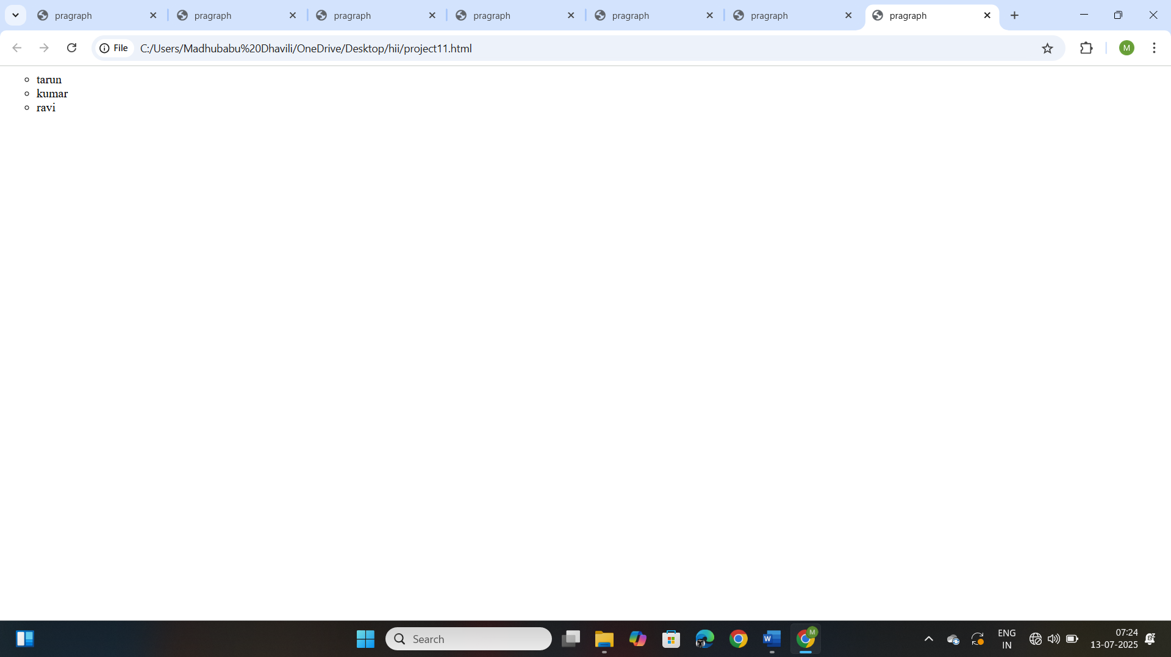

**Project-12**

**Titlte: Design a web page by demonstrating the usage of HTML list type attribute-“disc”:**

**Source code:**

<!DOCTYPE html>

<html>

    <head>

        <title>

            Second web page

        </title>

    </head>

    <body>

        <ul type="disc">

            <li>tarun</li>

            <li>kumar</li>

            <li>ravi</li>

        </ul>

    </body>

</html>

**Output:**

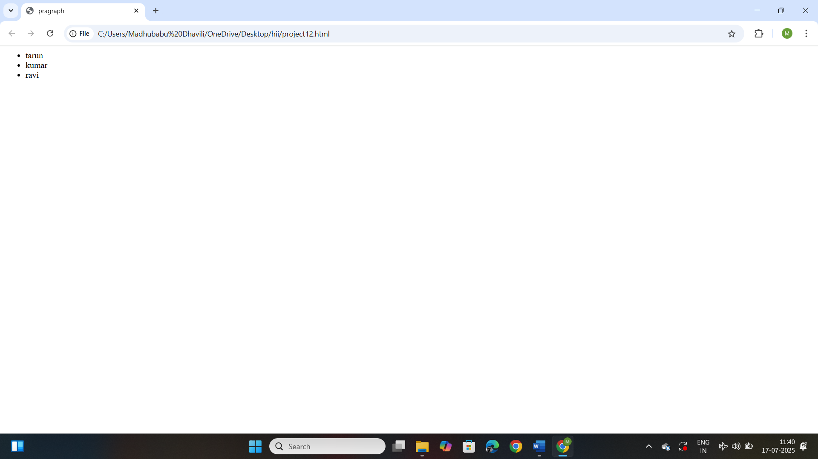

**Project-13**

**Titlte: Design a web page by demonstrating the usage of HTML list type attribute-“none”:**

**Source code:**

<!DOCTYPE html>

<html>

    <head>

        <title>

            Second web page

        </title>

    </head>

    <body>

        <ul type="none">

            <li>tarun</li>

            <li>kumar</li>

            <li>ravi</li>

        </ul>

    </body>

</html>

**Output:**

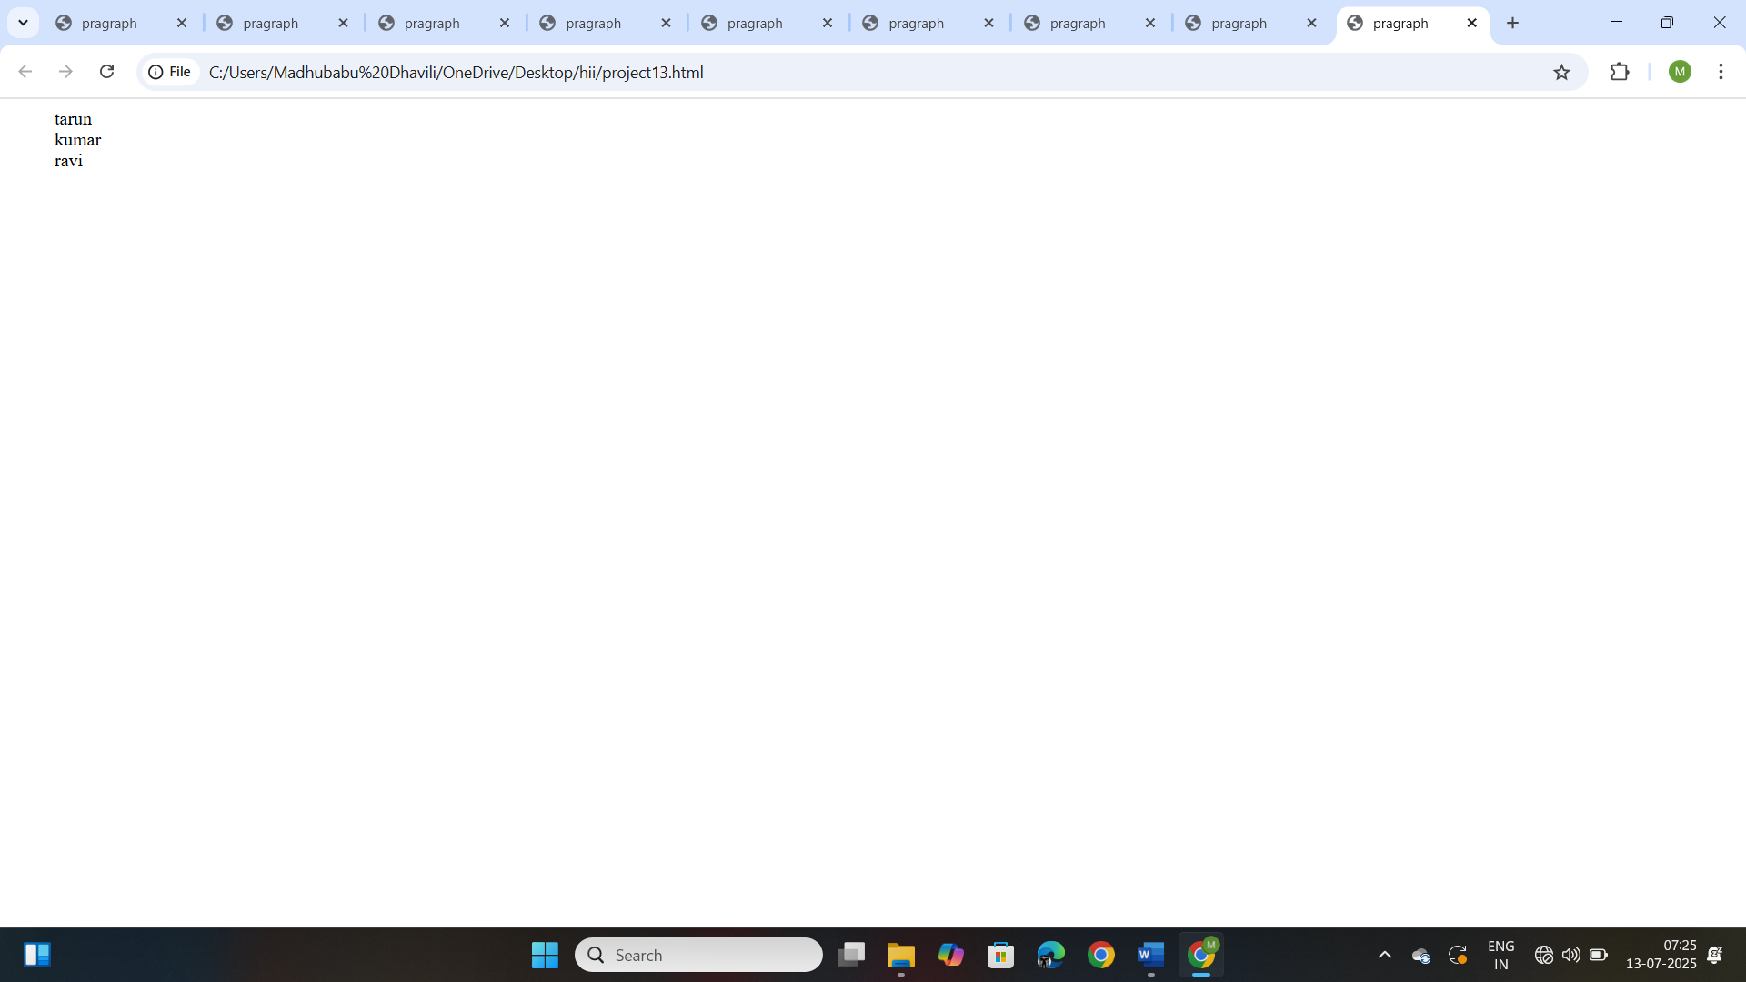

**Project-14**

**Titlte: Design a web page by demonstrating the usage of Nested list in HTML:**

**Source code:**

<!DOCTYPE html>

<html>

    <head>

        <title>

            Second web page

        </title>

    </head>

    <body>

        <ol>

            <li>14 pro</li>

            <li>15 pro</li>

        </ol>

        <li> goggle pixel</li>

        <ol>

            <li>9flod</li>

            <li>9 pro</li>

        </ol>

    </body>

</html>

**Output:**

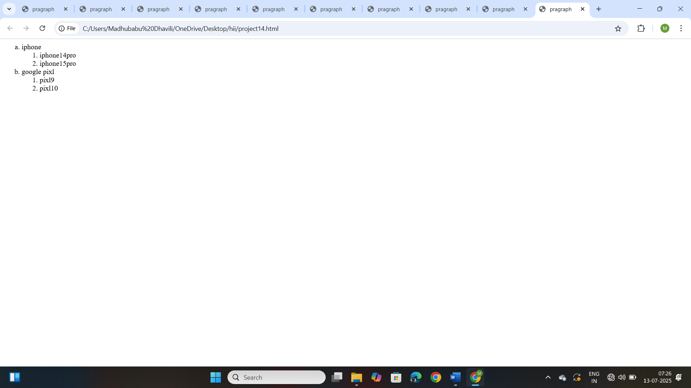

**Project-15**

**Title: Design a web page by demonstrating the usage of HTML Table Tag:**

**Source Code:**

<!DOCTYPE html>

<html>

    <head>

        <title> Table tag</title>

    </head>

    <body>

        <table border="1">

            <tr>

                <th>Name</th>

                <th>Age</th>

                <th>City</th>

            </tr>

            <tr>

                <td>john</td>

                <td>28</td>

                <td>New York</td>

           </tr>

           <tr>

            <td>Emma</td>

            <td>22</td>

            <td>Los Angles</td>

           </tr>

        </table>

    </body>

</html>

**Output:**

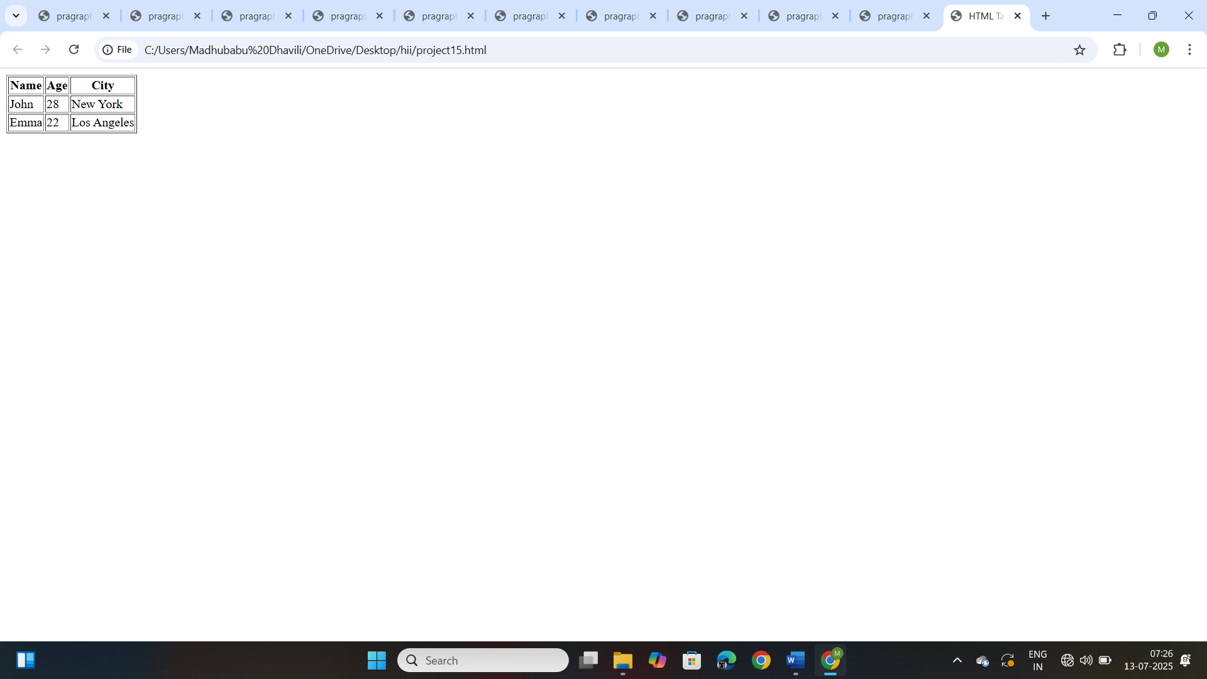

**Project-16**

**Title: Design a web page by demonstrating the usage of HTML. Image Tag.**

**Source Code:**

<!DOCTYPE html>

<html>

<head>

    <title> HTML image</title>

</head>

<body>

    <img src="india.jpg" alt="india flag" height="500" width="700">

</body>

</html>

**Output:**

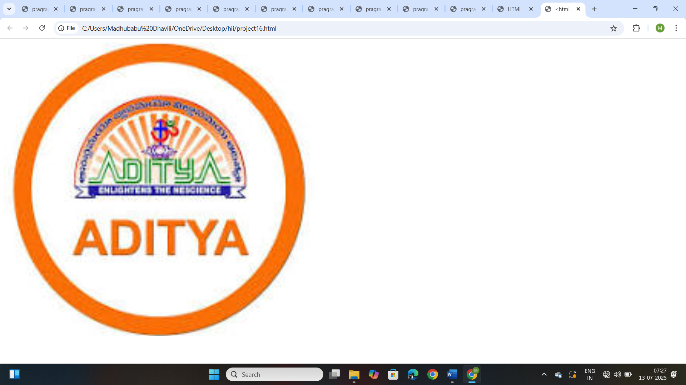

**Project-17**

**Title: Design a web page by demonstrating the usage of HTML. Video Tag.**

**Source Code:**

<!DOCTYPE html>

<html>

    <head>

        <title>

            HTML video

        </title>

        <body>

            <video src="Tree.mp4" height="300" width="600" controls></video>

        </body>

    </head>

</html>

**Output:**

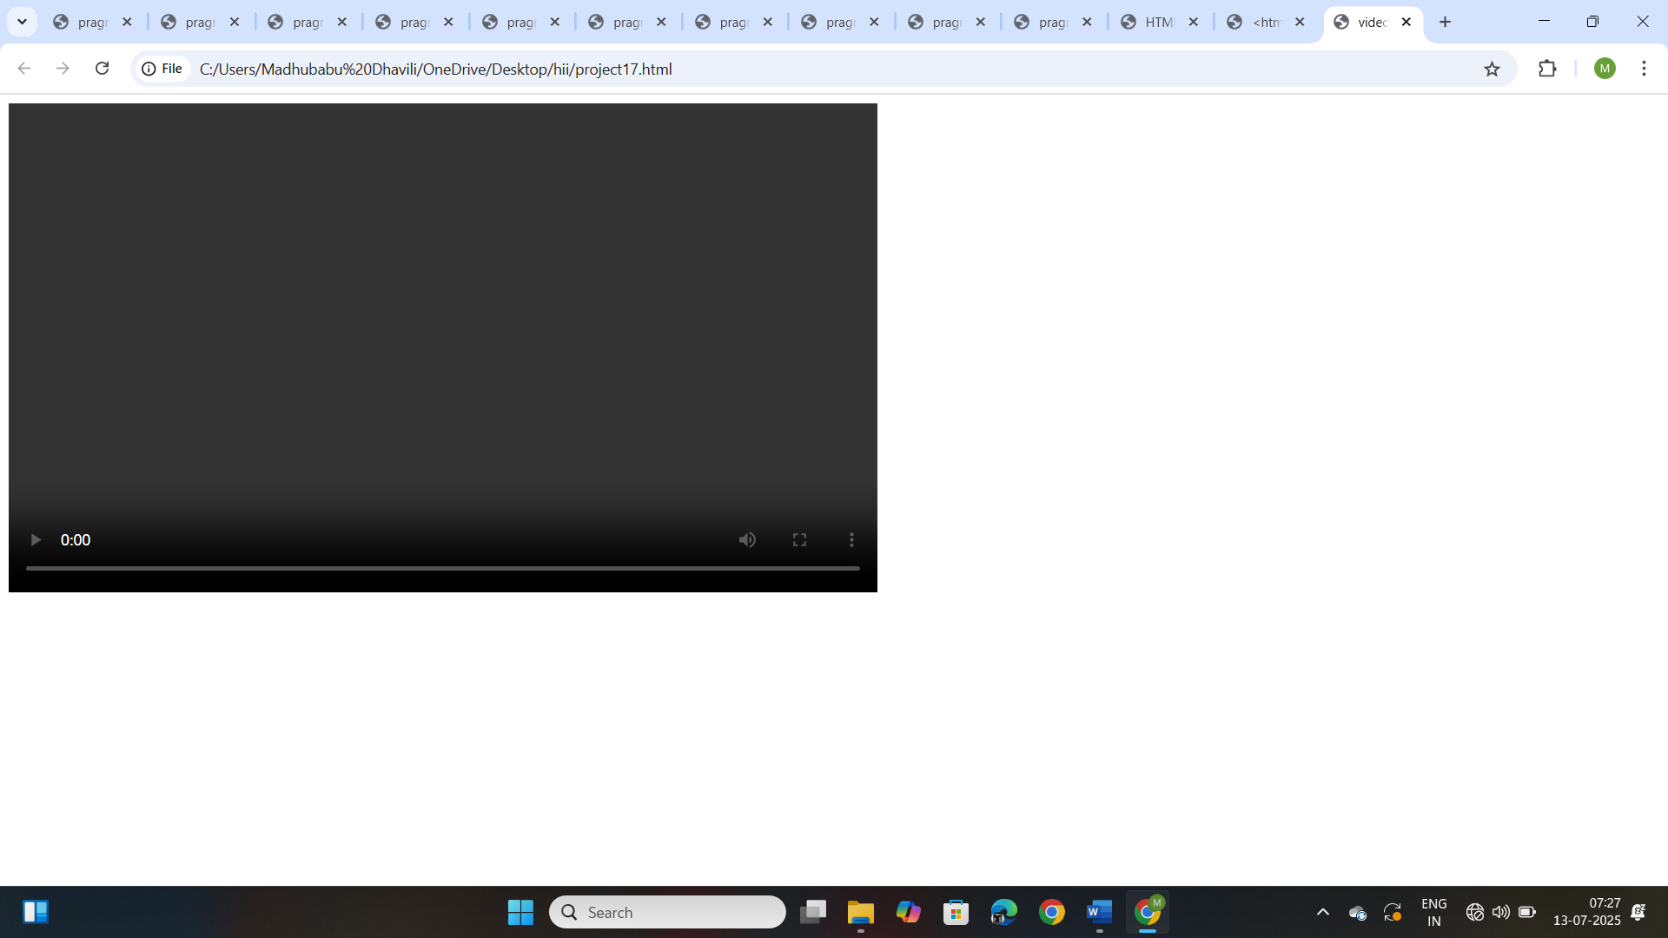

**Project-18**

**Title: Design a web page by demonstrating the usage of HTML. Audio Tag.**

**Source Code:**

<!DOCTYPE html>

<html>

    <head>

        <title>

            HTML audoi

        </title>

        <body>

            <audio src ="Music.mp3" controls></audio>

        </body>

    </head>

</html>

**Output:**

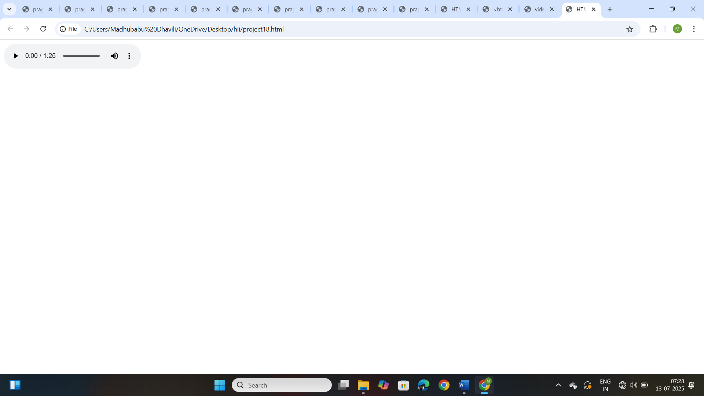

**Project-19**

**Title: Design a web page by demonstrating the usage of Div Tag:**

**Source Code:**

<!DOCTYPE html>

<html>

<head>

    <title>  Div container Example </title>/head>

<body>

    <div style="border: 10px solid black; padding: 10px;">

        <h2>Div container</h2>

        <p>This is a paragraph inside a div container</p>

    </div>

</body>

</html>

**Output:**

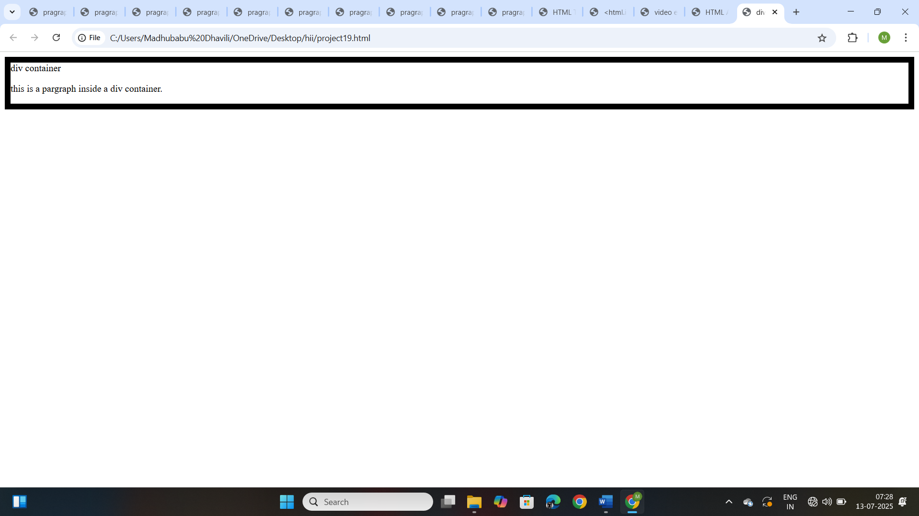

**Project-20**

**Title: Design a web page by demonstrating the usage of HTML Marquee Tag.**

**Source Code:**

<!DOCTYPE html>

<html>

<head>

    <title>  Marquee Tag Example </title>

</head>

<body>

    <h2>Scrolling Text Example</h2>

     <marquee>Welcome to our website! Stay tuned for updates. </marquee>

</body>

</html>

**Output:**

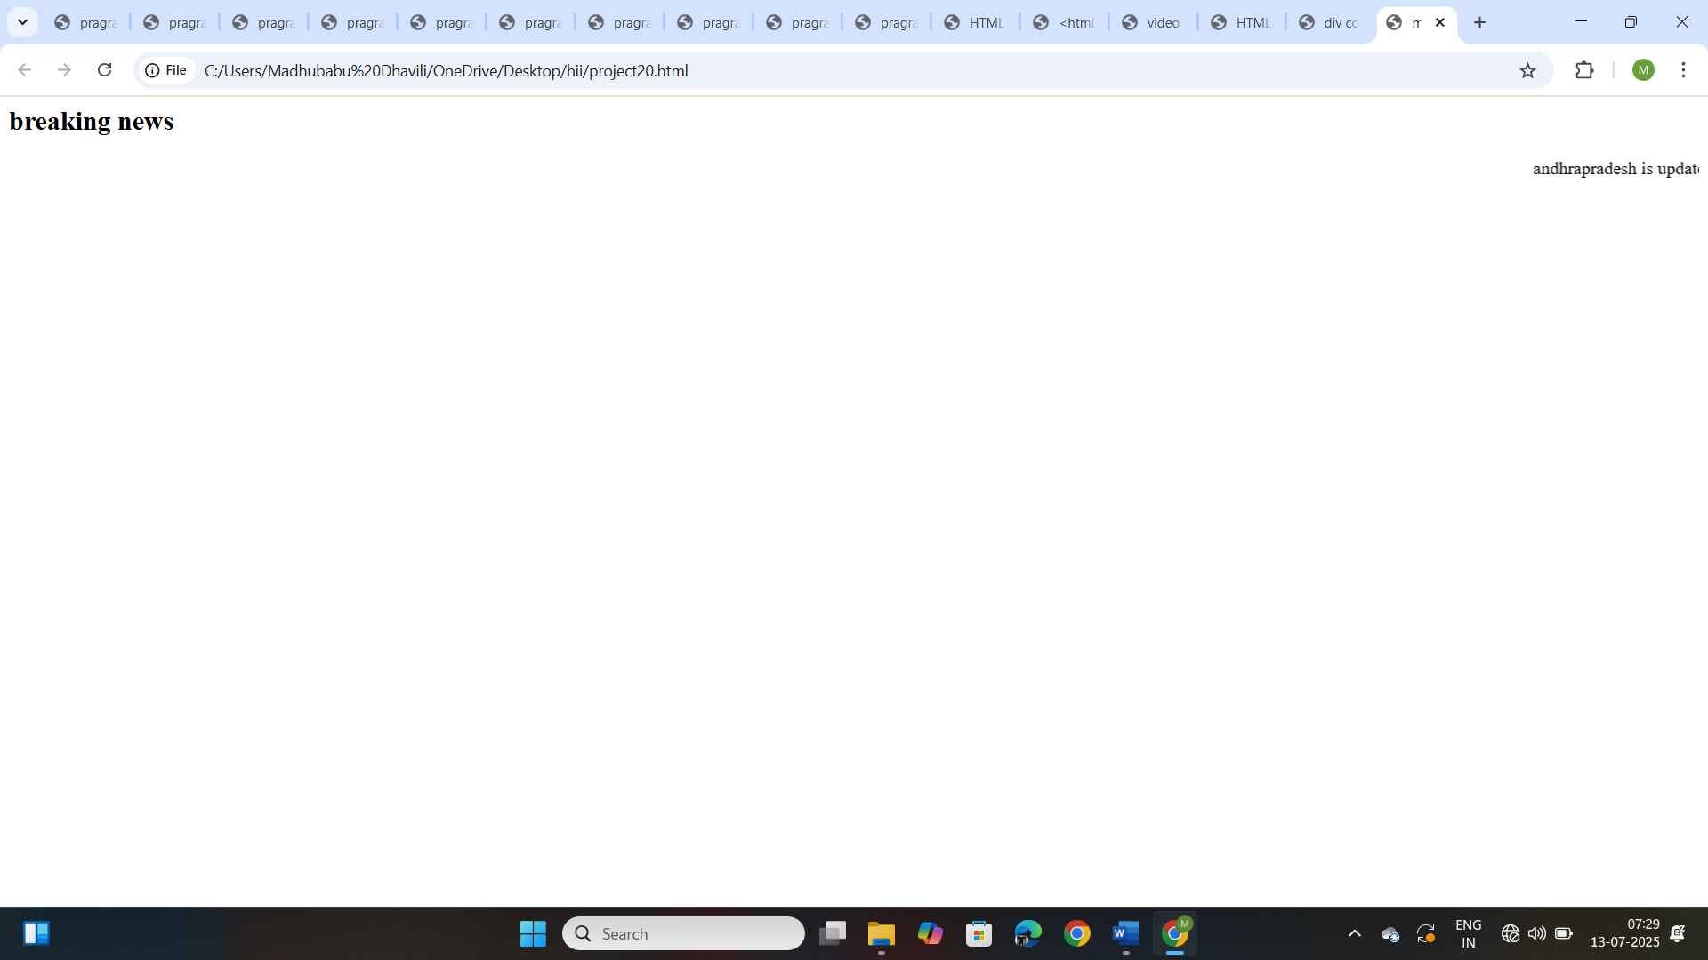

**Project-21**

**Title: Design a web page by demonstrating the usage of HTML Marquee Tag.**

**Source Code:**

<!DOCTYPE html>

<html>

<head>

    <title>  Marquee Tag </title>

</head>

<body>

   <h1>MARQUEE TAG</h1>

   <marquee direction="right" bgcolor="lightblue" width="50%" height="50px">Scrolling Left to Right</marquee>

   <marquee direction="left" bgcolor="lightgreen" width="80%" height="50px">Scrolling Right to Left</marquee>

   <marquee direction="down" bgcolor="lightcoral" width="50%" height="200px">

   <img src="india.jpg" alt="Scrolling Image1"> </marquee>

   <marquee direction="up" bgcolor="lightyellow" width="50%" height="200px">

    <img src="india.jpg" alt="Scrolling Image2"> </marquee>

</body>

</html>

**Output:**

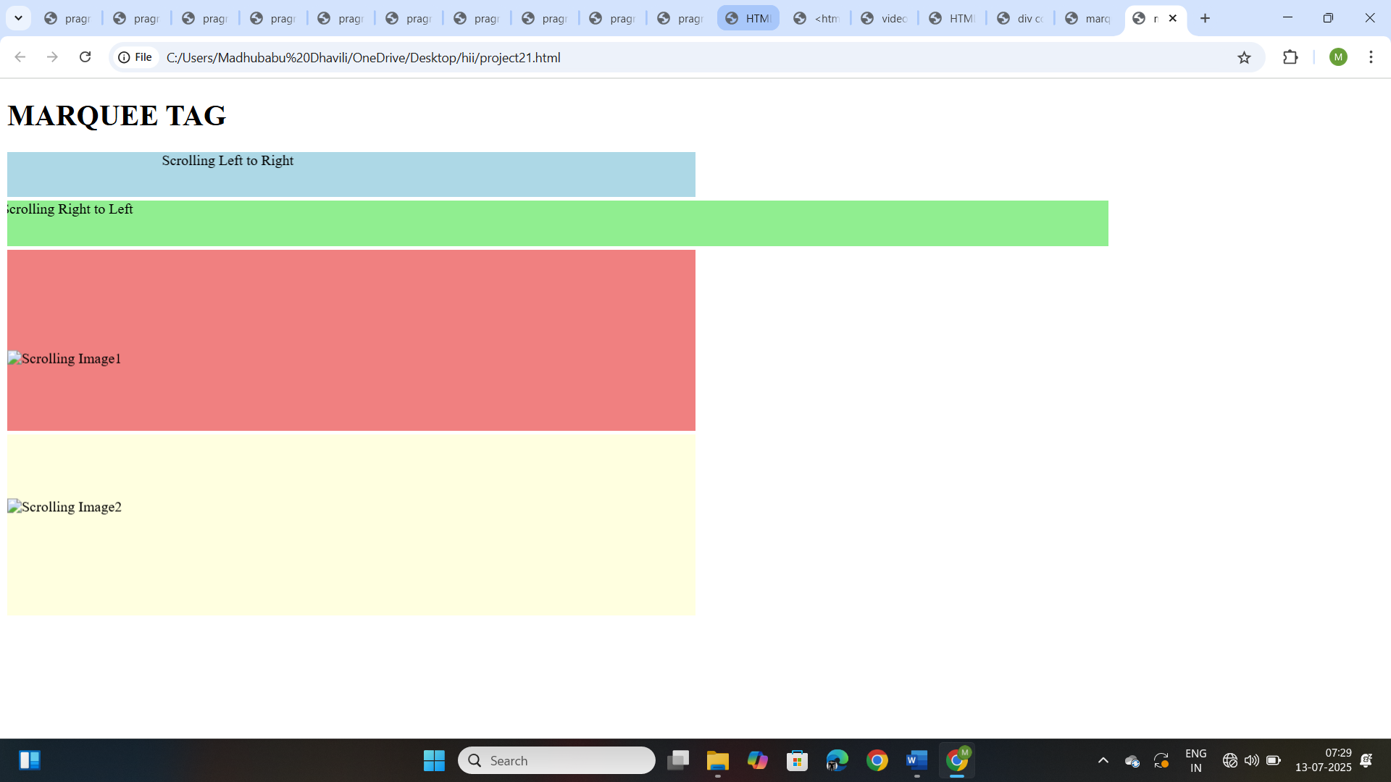

**Project-22**

**Title: Design a web page by demonstrating the usage of HTML Marquee Tag.**

**Source Code:**

<!DOCTYPE html>

<html>

    <head>

        <title>Image Background</title>

    </head>

    <body background="india.jpg">

        <p>Laptops are poratable computers designed to be carried around, making them ideal for use  various locations like home, office, or on the go. They are powered by batteries,</p>

    </body>

</html>

**Output:**

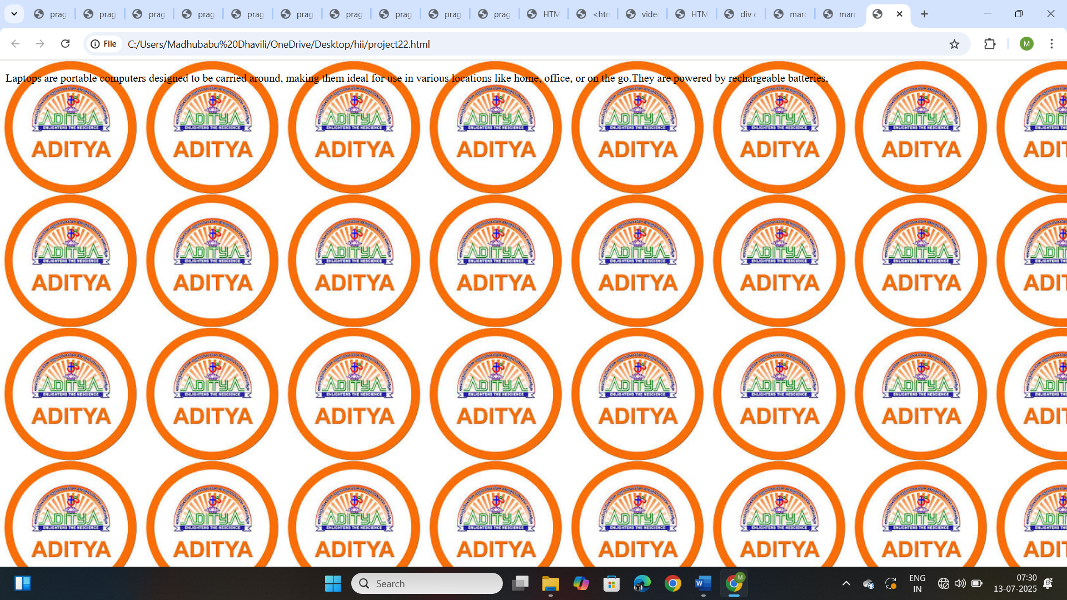

**Project-23**

**Title: Design a web page by demonstrating the usage of HTML Rowspan and colspan attributes in a table:**

**Source Code:**

<!DOCTYPE html>

<html>

    <head>

        <title> Table with Colspan and Rowspan</title>

    </head>

    <body>

        <h2>Table Example with Colspan and Rowspam</h2>

        <p><strong>Collspan:</strong>This header spans across two columns.</p>

        <table border="1">

            <tr>

                <th colspan="2">Name</th>

                <th>Age</th>

            </tr>

            <tr>

                <td>yagna</td>

                <td>priya</td>

                <td>19</td>

           </tr>

           <tr>

            <td>bhagya</td>

            <td>laxmi</td>

            <td>18</td>

           </tr>

        </table>

        <br>

        <p><strong>Rowspan:</strong>This cell spans across two rows</p>

        <table border="1">

            <tr>

                <th>Name</th>

                <th>Age</th>

                <th rowspan="2">city</th>

            </tr>

            <tr>

                <td>likki</td>

                <td>20</td>

            </tr>

            <tr>

                <td>keerthi</td>

                <td>22</td>

                <td>srikakulam</td>

            </tr>

        </table>

    </body>

</html>

**Output:**

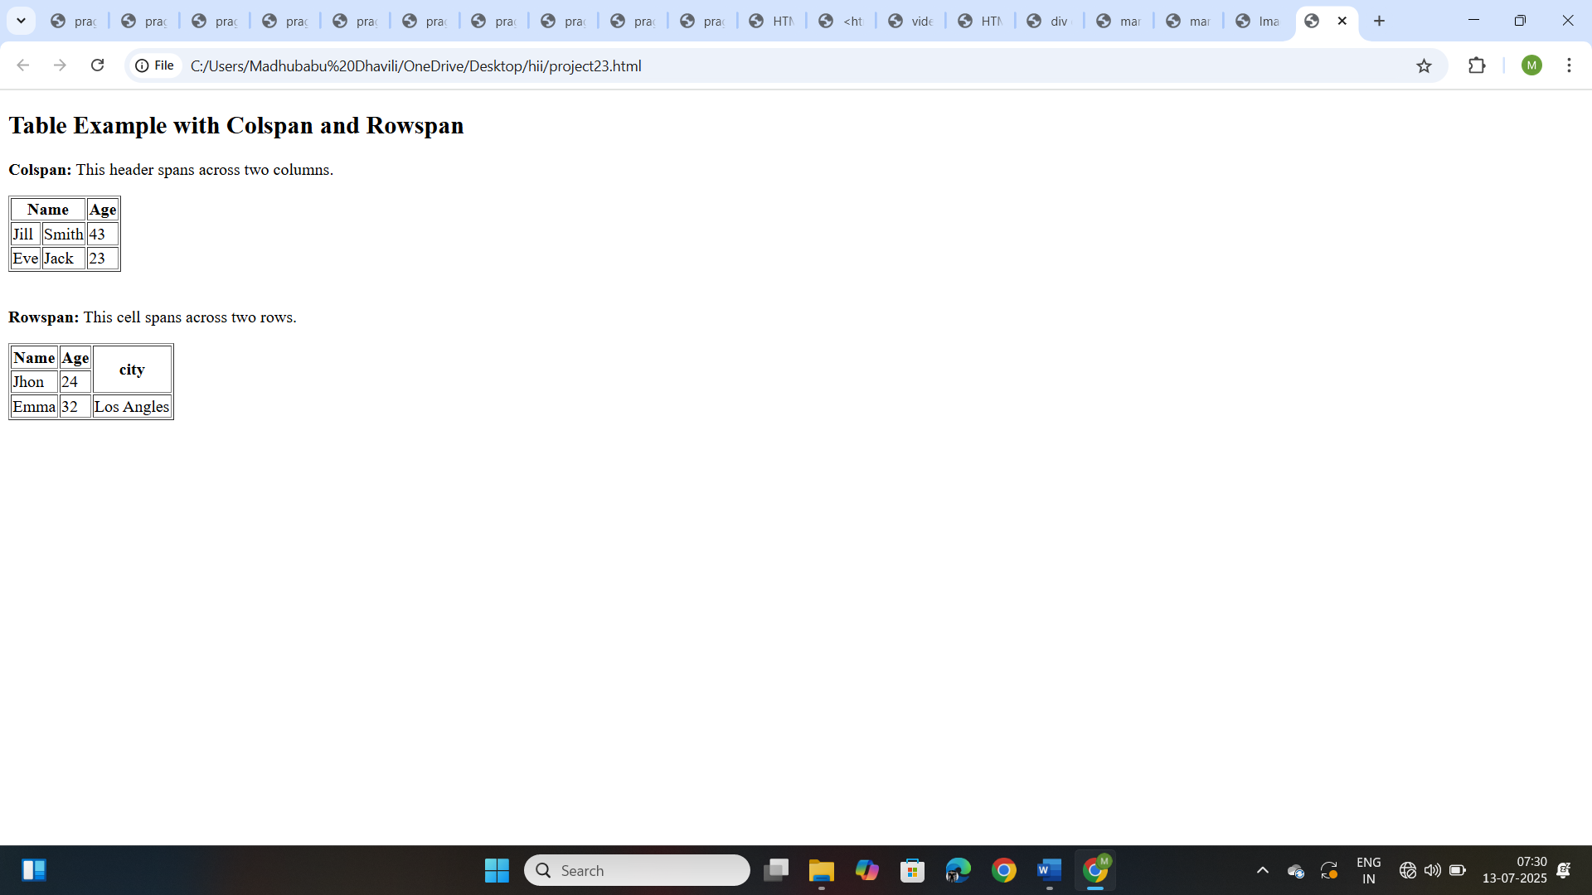

**Project-24**

**Title: Design create a web page by demonstrating the usage of HTML the <b> (bold) tag.**

**Source Code:**

<!DOCTYPE html>

<html>

    <head>

        <title><b>-Bold</title>

    </head>

    <body>

        <p>This is <b>bold</b>word.</p>

    </body>

</html>

**Output:**

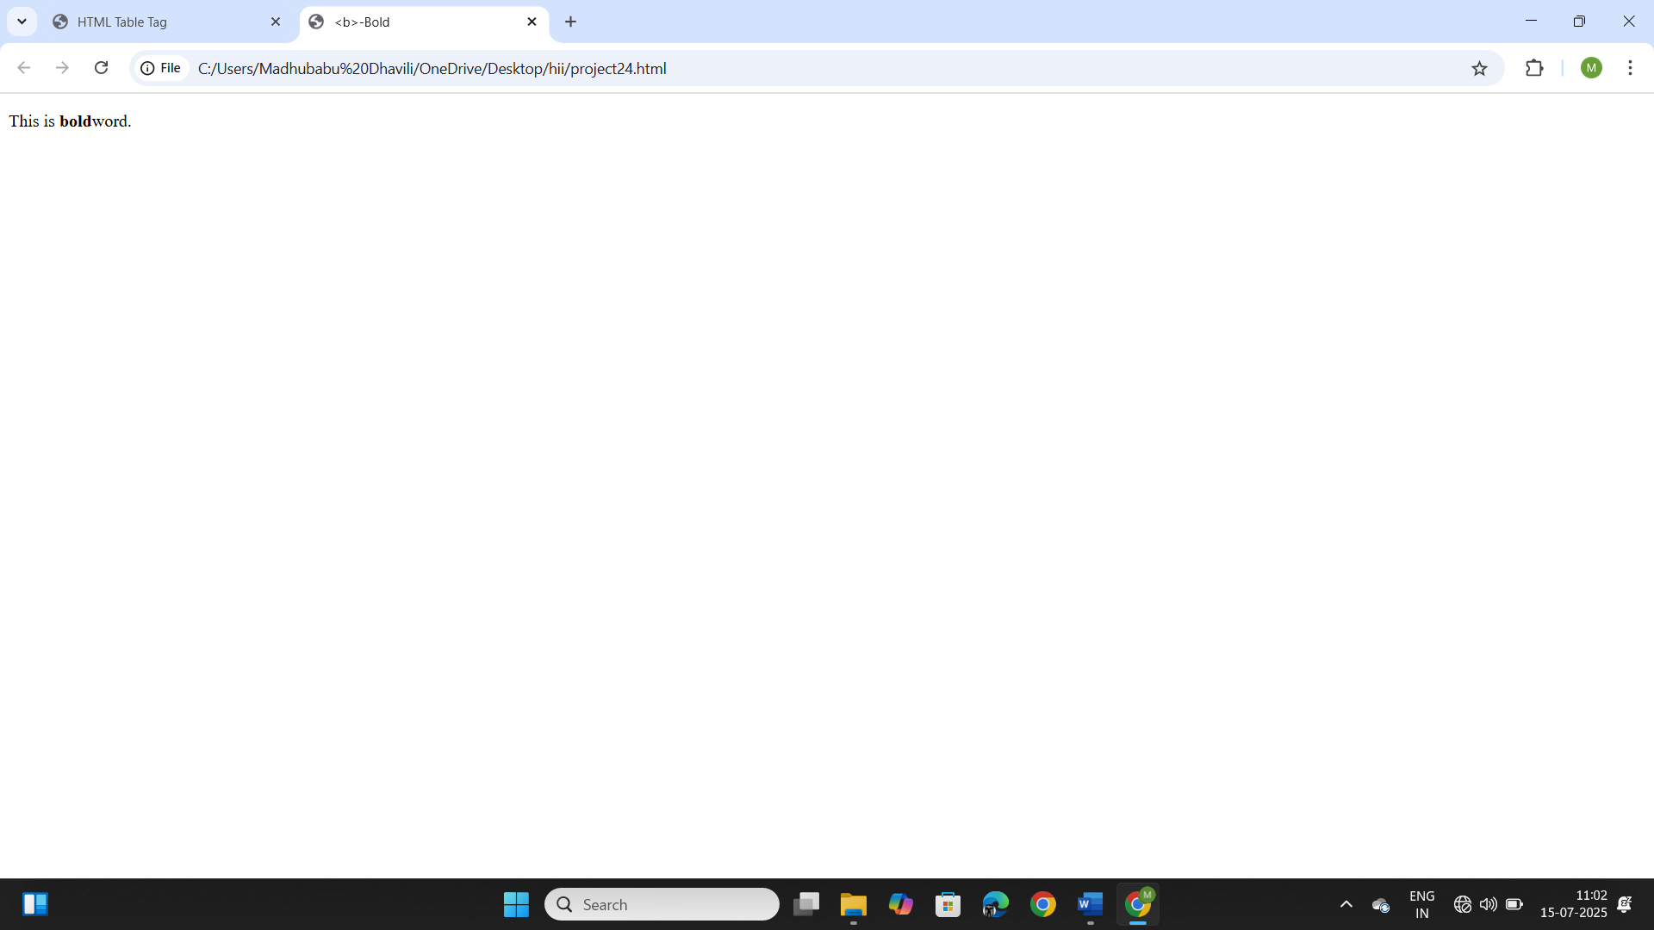

**Project-25**

**Title: Create a web page demonstrating the use of the <strong> tag.**

**Source Code:**

<!DOCTYPE html>

<html>

    <head>

        <title><strong>- Strong importance</title>

    </head>

    <body>

        <p>This is <strong>important </strong>text.</p>

    </body>

</html>

**Output:**

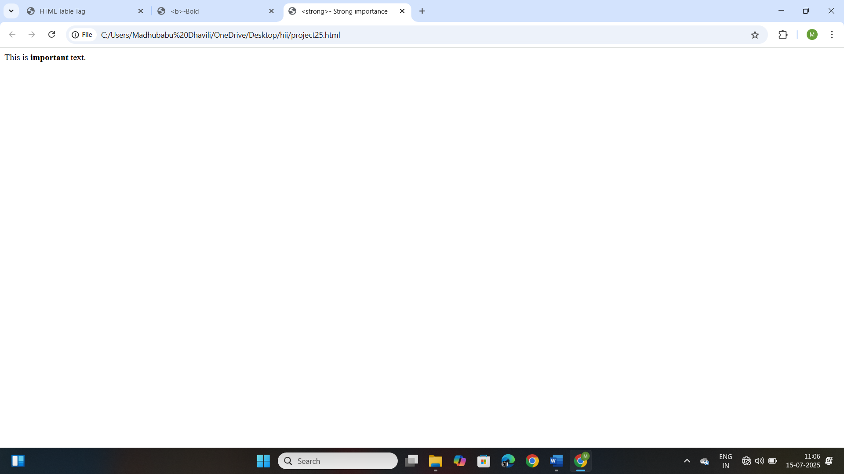

**Project-26**

**Title: Create a web page demonstrating the use of the <i> tag.**

**Source Code:**

<!DOCTYPE html>

<html>

    <head>

        <title><i>-Italic Text</title>

    </head>

    <body>

        <p>This is an <i>italic </i>word.</p>

    </body>

</html>

**Output:**

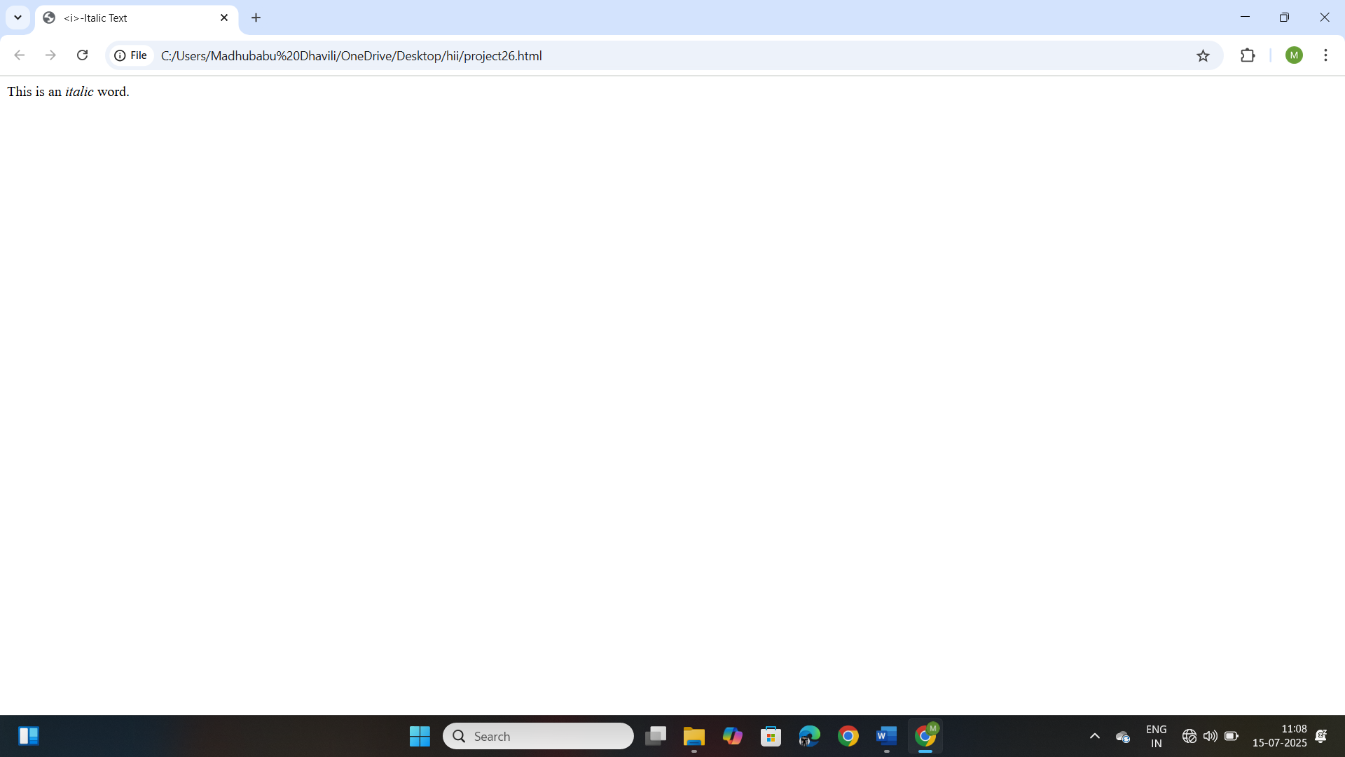

**Project-27**

**Title: Create a web page demonstrating the use of the <em> tag.**

**Source Code:**

<!DOCTYPE html>

<html>

    <head>

        <title><em>-Emphasized text</title>

    </head>

    <body>

        <p>This is <em>emphasized</em> text</p>

    </body>

</html>

**Output:**

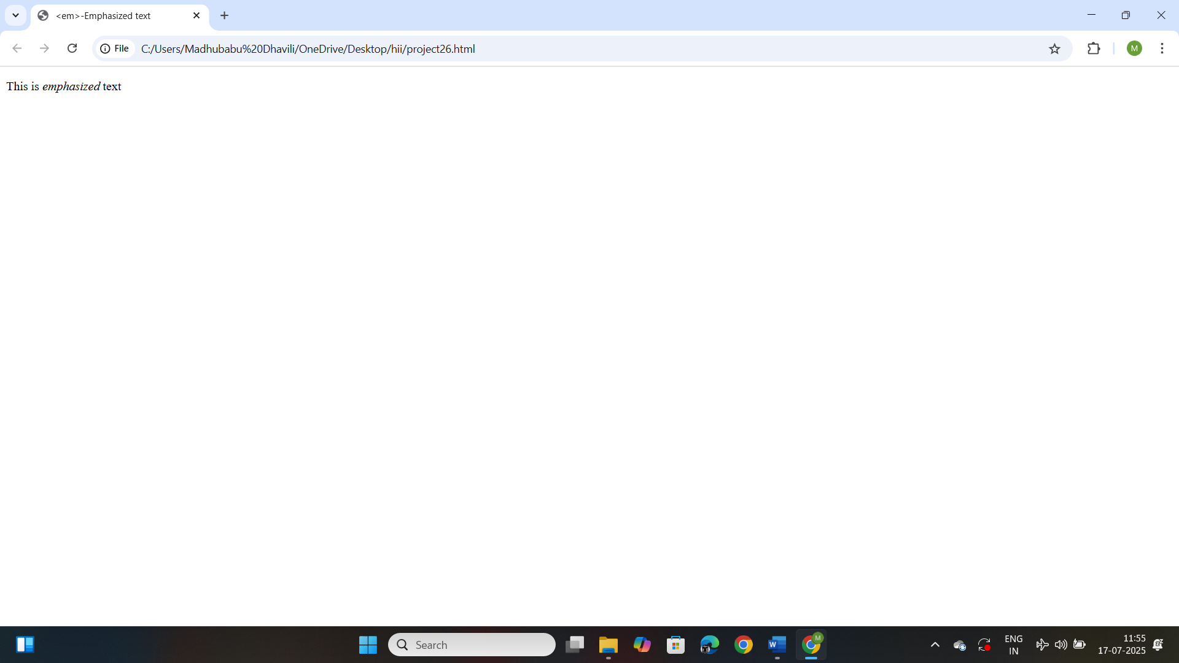

**Project-28**

**Title: Create a web page demonstrating the use of the <u> tag.**

**Source Code:**

<!DOCTYPE html>

<html>

    <head>

        <title><u>-Underlined Text</title>

    </head>

    <body>

        <p>This is an <u>Underlined</u> word.</p>

    </body>

</html>

**Output:**

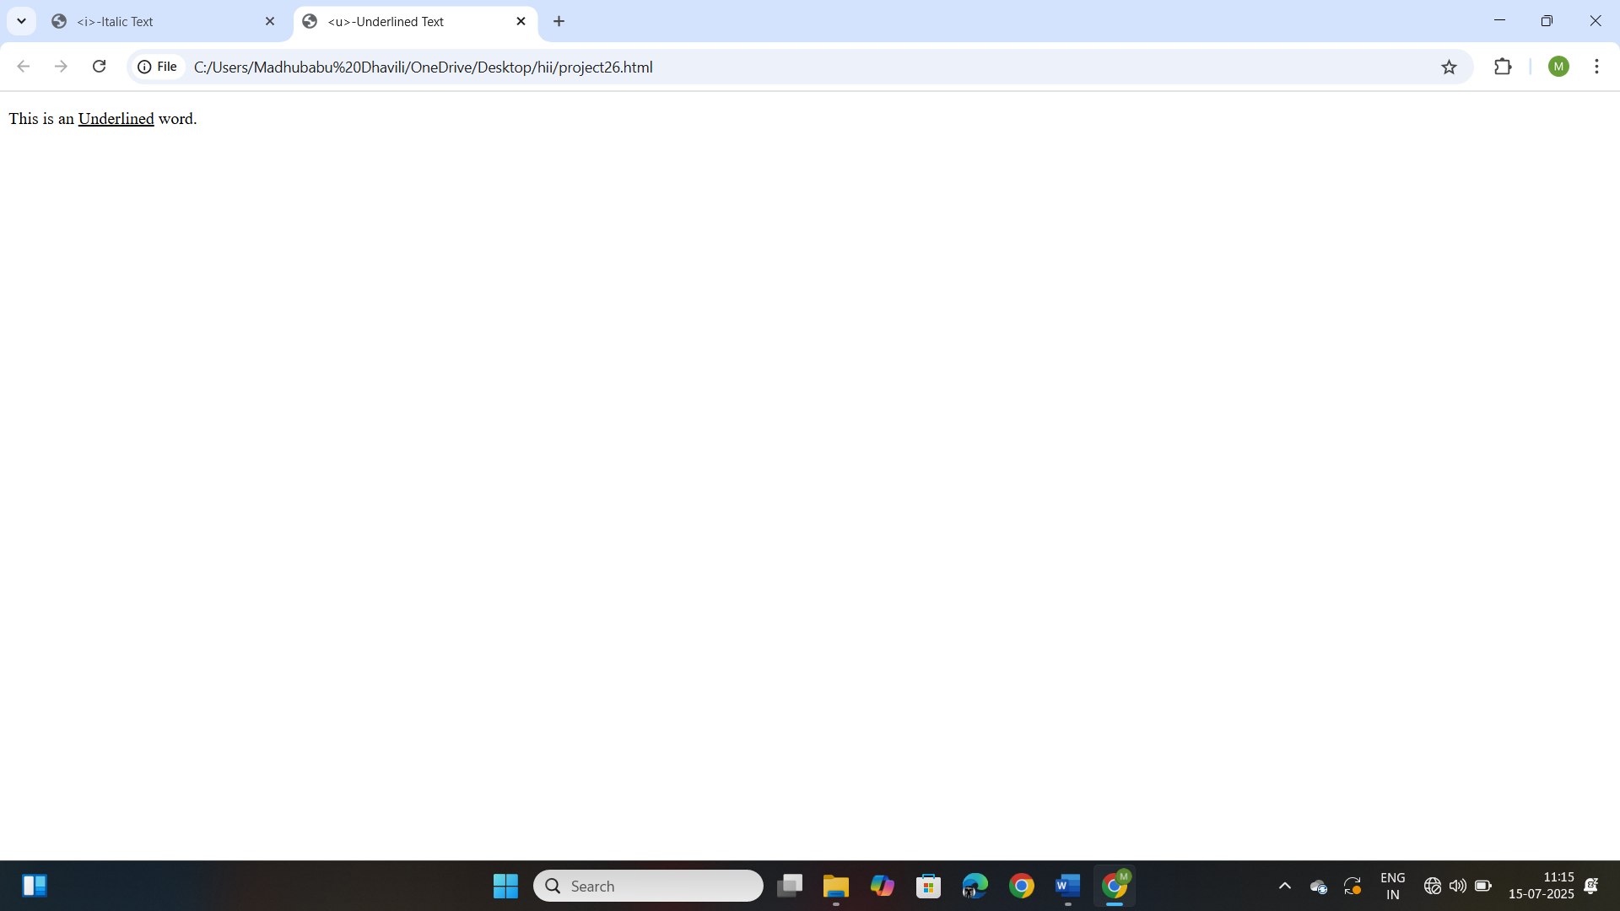

**Project-29**

**Title: Create a web page demonstrating the use of the <mark> tag.**

**Source Code:**

<!DOCTYPE html>

<html>

    <head>

        <title><mark>-Highlighted Text</title>

    </head>

    <body>

        <p>This is a <mark>highlighted</mark> word.</p>

    </body>

</html>

**Output:**

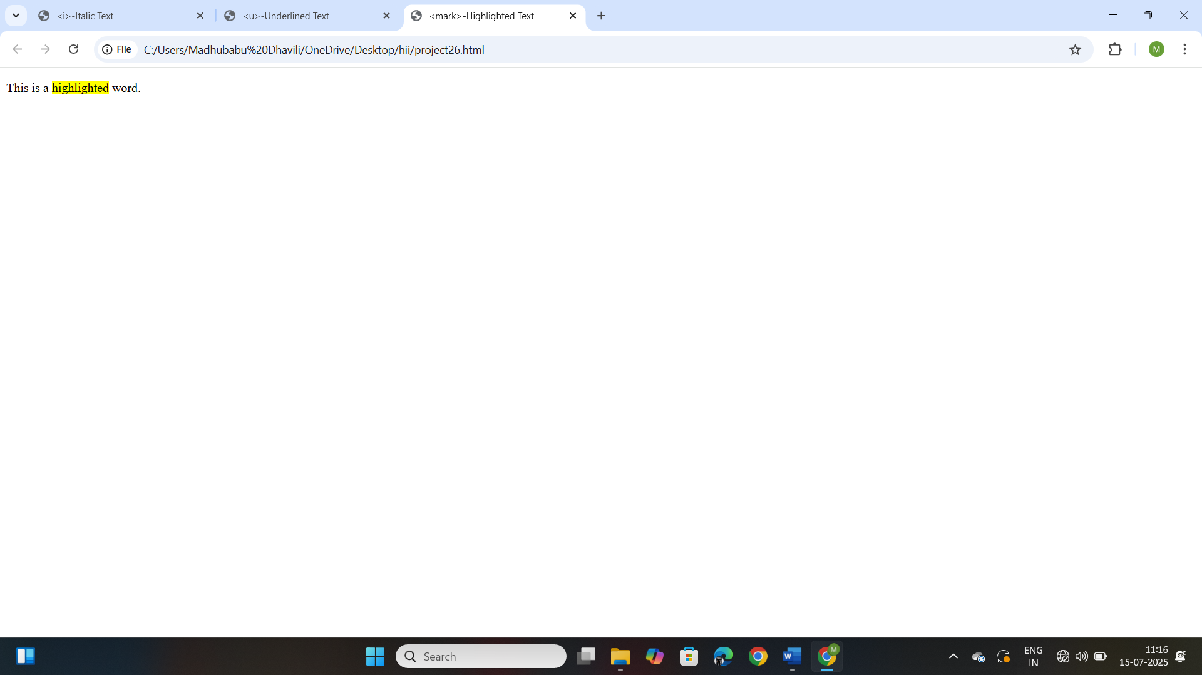

**Project-30**

**Title: Create a web page demonstrating the use of the <small> tag.**

**Source Code:**

<!DOCTYPE html>

<html>

    <head>

        <title><small>-Smaller Text</title>

    </head>

    <body>

        <p>This is a <small>smaller</small> text.</p>

    </body>

</html>

**Output:**

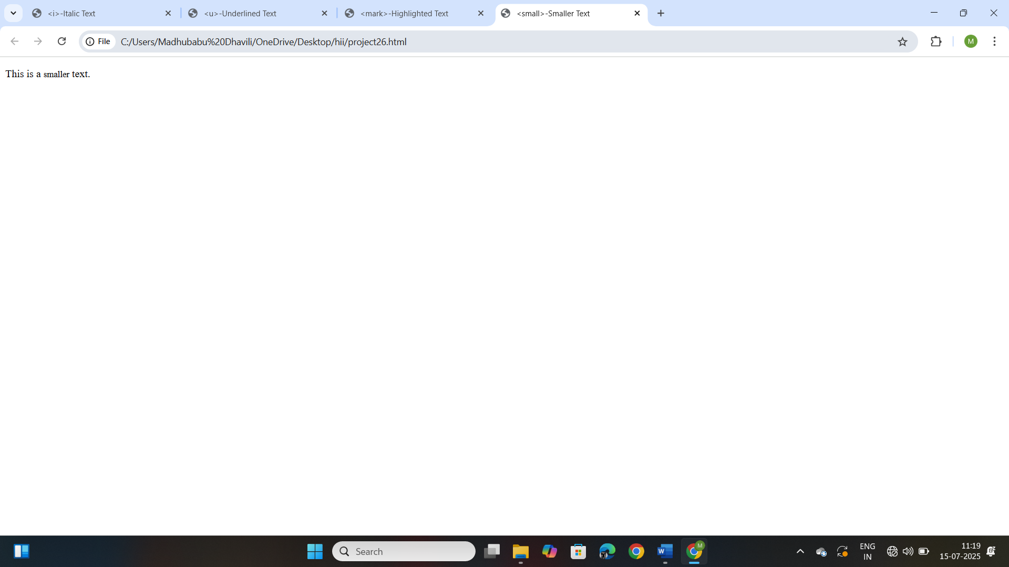

**Project-31**

**Title: Design a web page to open an external link.**

**Source Code:**

<!DOCTYPE html>

<html>

    <head>

        <title>External Link Example</title>

    </head>

    <body>

        <h2>External Website Link</h2>

        <p>

            Click the link below

        </p>

        <a href="https://www.google.com/webhp?hl=en&sa=X&sqi=2&ved=0ahUKEwii3qrAjaiNAxUTXGwGHRX_J-sQPAgI" target="_blank"> Visit google</a>

    </body>

</html>

**Output:**

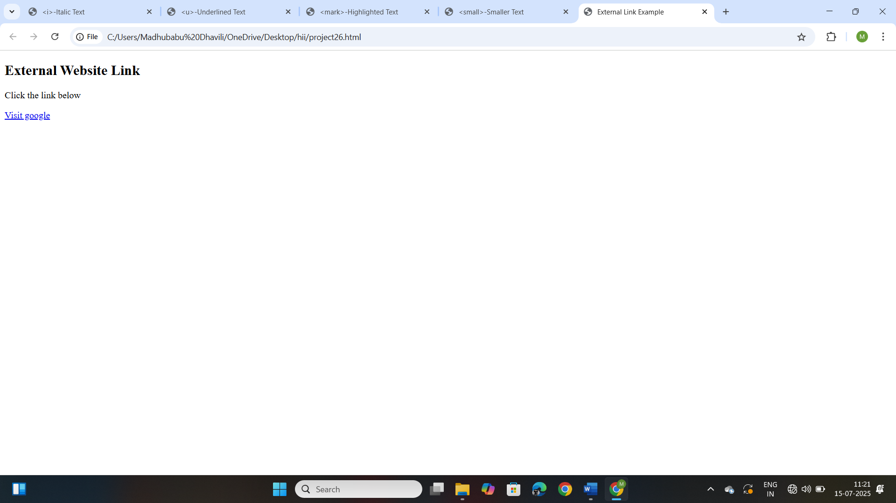

**Project-32**

**Title: Design a web page to open an mailto link**

**Source Code:**

<!DOCTYPE html>

<html>

    <head>

        <title>Send Email</title>

    </head>

    <body>

        <h2>Contact us</h2>

        <p>

            Click the link below to send us an email:

        </p>

        <a href="yagnapriyakanithi@gmail.com">Send Email</a>

    </body>

</html>

**Output:**

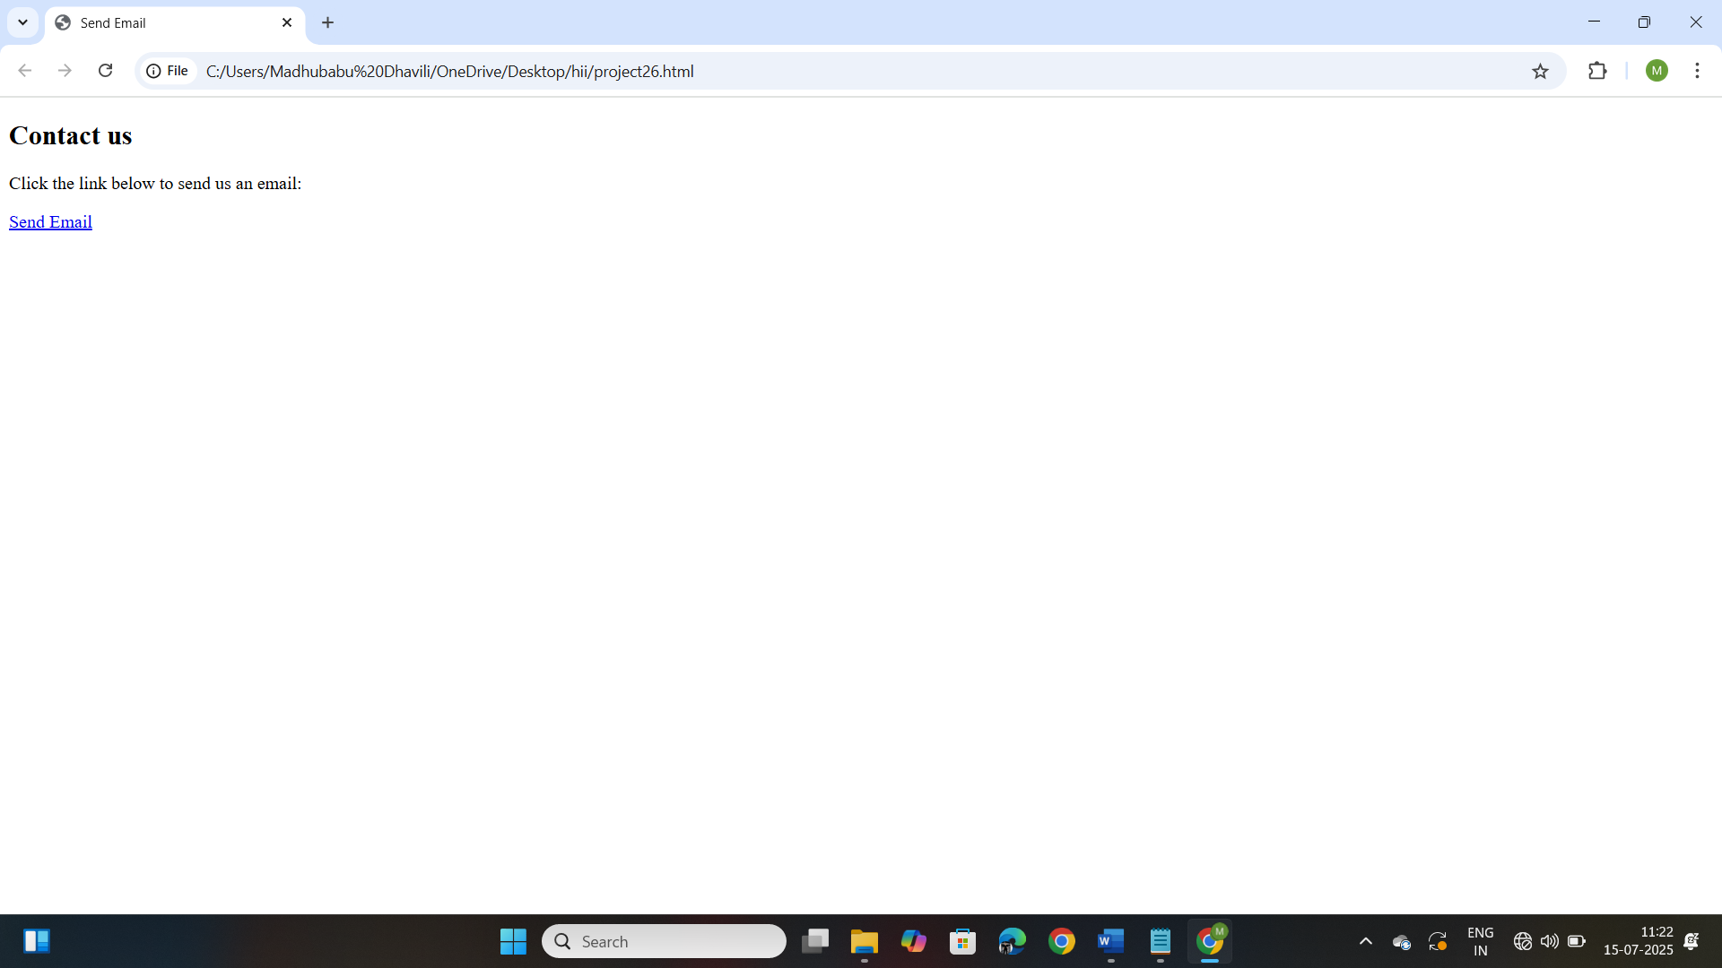

**Project-33**

**Title: Phone number link:**

**Source Code:**

<!DOCTYPE html>

<html>

    <head>

        <title>Call us</title>

    </head>

    <body>

        <h2>Contact us</h2>

        <p>

            Click the link below to call us:

        </p>

        <a href="tel:9494163331"> Call 123-456</a>

    </body>

</html>

**Output:**

